

Student Name……………………………………

FURTHER MATHEMATICS

TRIAL EXAMINATION 1

2013

Reading Time: 15 minutes
Writing time: 1 hour 30 minutes

Instructions to students
This exam consists of Section A and Section B.
Section A contains 13 multiple-choice questions from the core, 'Data Analysis'.
Section A is compulsory and is worth 13 marks.
Section B consists of 6 modules each containing 9 multiple-choice questions. You should choose 3 of these modules and answer every question in each of your chosen modules.
Each of the modules is worth 9 marks.
Section B begins on page 10 of this exam.
There is a total of 40 marks available for this exam.
Unless otherwise stated the diagrams in this exam are not drawn to scale.
Students may bring one bound reference into the exam.
An approved graphics or CAS calculator may be used in the exam.
An answer sheet appears on page 42 of this exam.
Formula sheets can be found on pages 40 and 41 of this exam.

This paper has been prepared independently of the Victorian Curriculum and Assessment Authority to provide additional exam preparation for students. Although references have been reproduced with permission of the Victorian Curriculum and Assessment Authority, the publication is in no way connected with or endorsed by the Victorian Curriculum and Assessment Authority.

© THE HEFFERNAN GROUP 2013
This Trial Exam is licensed on a non transferable basis to the purchasing school. It may be copied by the school which has purchased it. This license does not permit distribution or copying of this Trial Exam by any other party.

SECTION A

CORE – Data Analysis

This section is compulsory.

The following information relates to questions 1 and 2.

The ordered stem plot below shows the number of VCE students enrolled in each of 24 rural schools.

Number of VCE students
2 | 7
3 | 8 | 9 | 9
4 | 4 | 4 | 5 | 7 | 7 | 7 | 8
5 | 1 | 3 | 3 | 4 | 6 | 8 | 9 | 9
6 | 0 | 2 | 2 | 7 | 8

Question 1

The mode of this data is

- 2
- 7
- 47
- 52
- 53

Question 2

The interquartile range (IQR) for this data is

- 13.5
- 14
- 14.5
- 15
- 52

Question 3

A group of 15 Year 6 students were asked how many laptops they had in their households. Their responses are displayed on the dot plot below

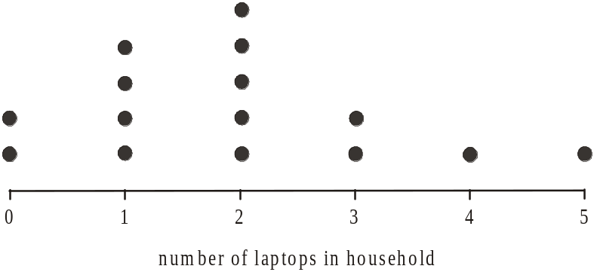

The mean and standard deviation of this set of data, expressed correct to one decimal place, are respectively

- 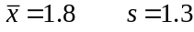
- 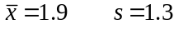
- 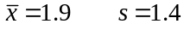
- 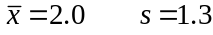
- 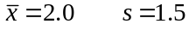

Question 4

The weight of a two litre container of a certain brand of fabric conditioner, is normally distributed with a mean of 2100g and a standard deviation of 3g.
This means that 5% of such containers should weigh

- between 2091g and 2109g
- between 2094g and 2106g
- less than 2091g and more than 2109g
- less than 2094g and more than 2106g
- less than 2097g and more than 2103g

Question 5

The table below shows the percentage of students who have and who don't have a learners permit to drive a car, in Years 10, 11 and 12 at a secondary school.

 | Year Level
 | 10 | 11 | 12
Students who have a learners permit | 23.7% | 52.1% | 73.4%
Students who don’t have a learners permit | 76.3% | 47.9% | 26.6%

There are 140 students in Year 12 at the school.
The number of Year 12 students who don’t have a learners permit is closest to

- 33
- 37
- 67
- 103
- 107

Question 6

The boxplots below show the distribution of rents, in dollars per square metre per year, paid by retail tenants at three different shopping centres – Broadside, Upsville and Lowtown.
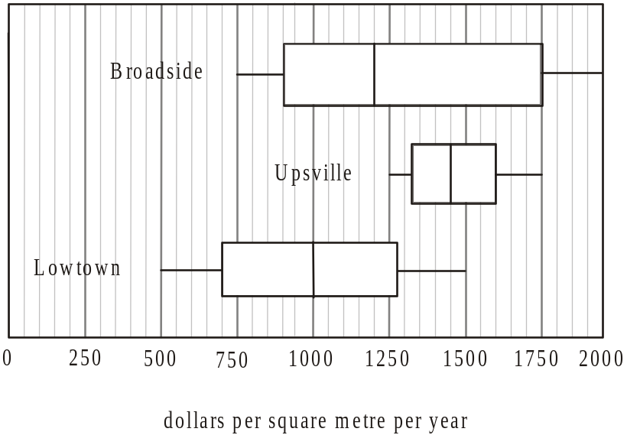

According to the boxplots, which one of the statements below is not true?

- At Broadside, more than half the retail tenants pay less rent than any of the retail tenants at Upsville.
- At Broadside, the range of rents paid by the retail tenants is more than twice the range of rents paid by retail tenants at Upsville.
- At Upsville approximately 75% of the retail tenants pay more rent than 75% of the retail tenants at Lowtown.
- At Lowtown the median rent paid by retail tenants is less than the rent paid by 75% of retail tenants at Broadside.
- At Lowtown more than 25% of retail tenants pay more than the median rent paid by retail tenants at Broadside.
The following information relates to questions 7 and 8.

The table below shows the weight (to the nearest kg) of twelve clients attending a weight-loss program, at their final session and at their initial session.

client | final weight  (kg) | initial weight  (kg)
1 | 74 | 87
2 | 71 | 76
3 | 78 | 82
4 | 80 | 91
5 | 65 | 79
6 | 82 | 95
7 | 87 | 98
8 | 71 | 87
9 | 69 | 75
10 | 86 | 93
11 | 78 | 84
12 | 83 | 89

Question 7

The variable final weight is taken as the dependent variable and a least squares regression line is fitted to the data.
The equation of this least squares regression line is closest to

Question 8

Pearson’s product-moment correlation coefficient for the variables final weight and initial weight is closest to

- 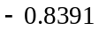
- 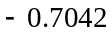
- 0.7042
- 0.7984
- 0.8391

Question 9

A set of bivariate data involves the independent variable x. The mean of x is 31.38 and the standard deviation is 5.38.
The other variable is y and the mean of y is 19.46 and the standard deviation is 5.46.
Pearson’s correlation coefficient is – 0.813.
The least squares regression line for this data would have an equation closest to

- 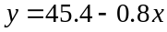
- 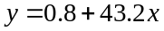
- 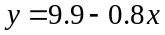
- 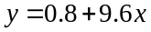
- 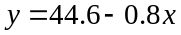

Question 10

The number of patrons who lunch at an open air café during February and the maximum temperature (in degrees Celsius) for each of those days during February are shown on the scatterplot below.
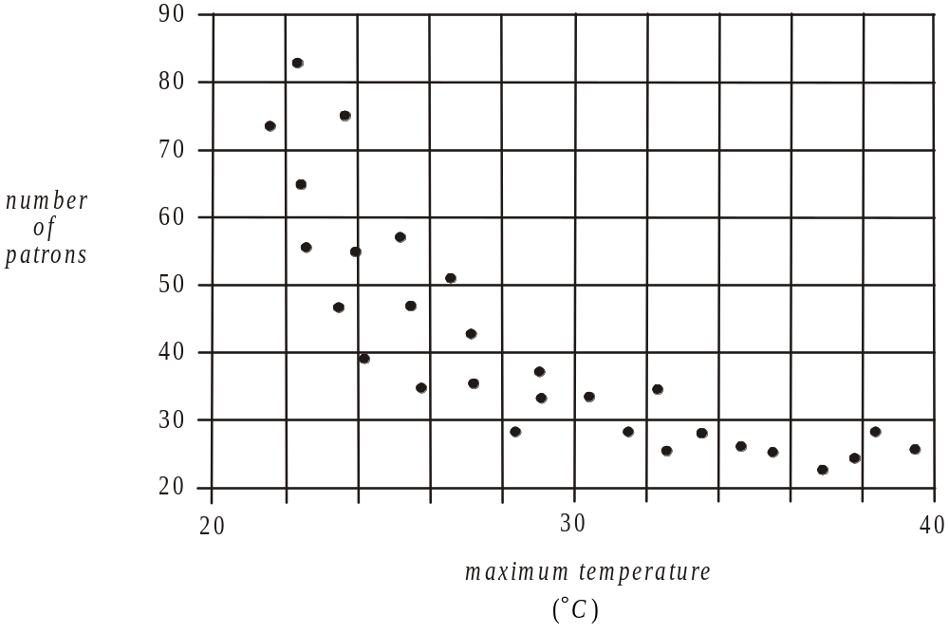

The data is clearly non-linear.
In an effort to linearise the data a transformed plot is attempted.
A plot that would not be useful in achieving this is

- number of patrons against 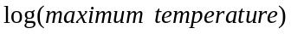
- 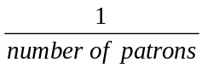 against maximum temperature
- number of patrons against 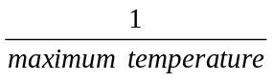
- 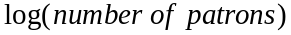 against maximum temperature
- number of patrons against (maximum temperature)²

Question 11

The scatterplot below shows the relationship between the variables y and x.

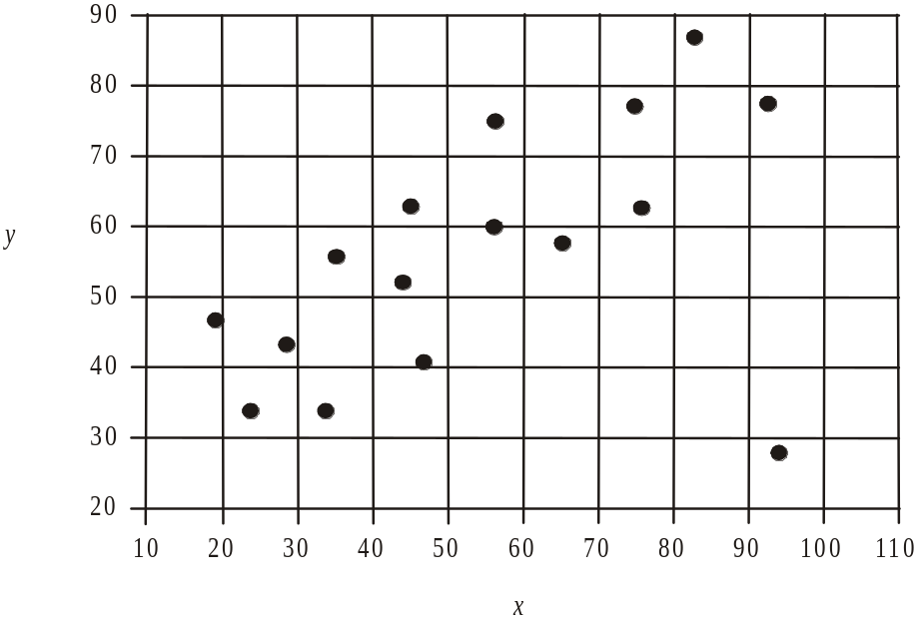

When fitting a regression line to this data it is true that

- one of the variables would need to be categorical.
- a least squares regression line would be most appropriate.
- the data would first require a transformation to be applied to one of the variables.
- a 3-median regression line would be most appropriate.
- the outlier should be removed.

Question 12

The time series plot below shows monthly sales of an online shoe store during 2012.

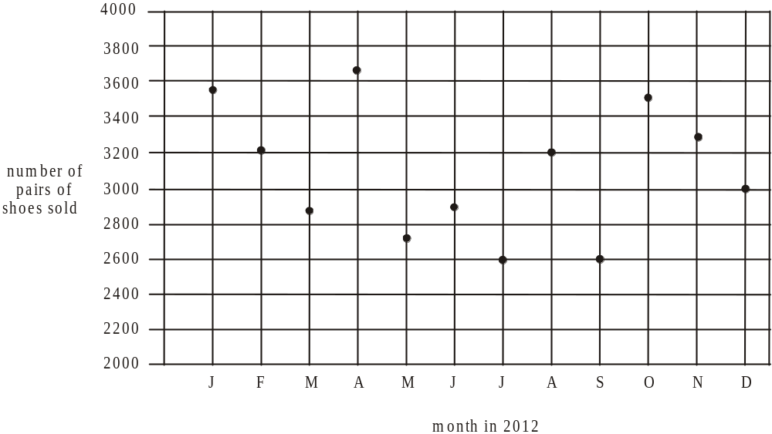

This plot is smoothed using five-point median smoothing. The smoothed number of pairs of shoes sold in August is closest to

- 2 600
- 2 900
- 2 960
- 3 000
- 3 200

Question 13

The time series plot below shows the quarterly profits of a company for the period 2008 – 2012.

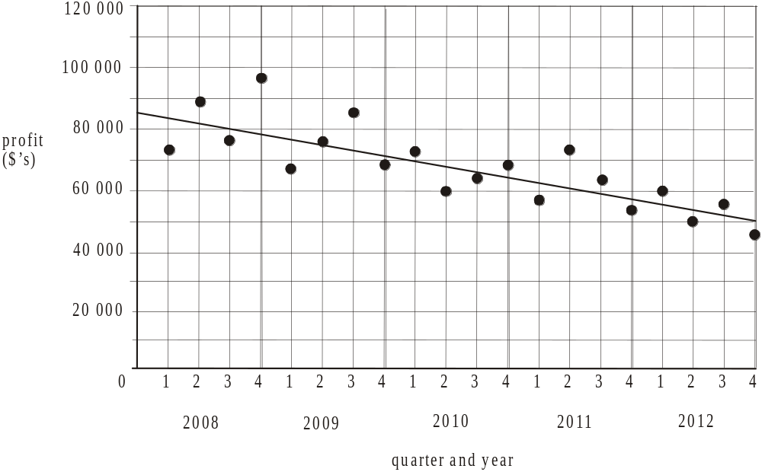

A regression line has been fitted by eye to this data.
According to this regression line, there was on average a quarterly

- increase in profit of $30 500
- increase in profit of $1 525
- decrease in profit of $30 500
- decrease in profit of $1 750
- decrease in profit of $1 525

SECTION B

Module 1: Number patterns

If you choose this module all questions must be answered.

Question 1

The tenth term of the sequence 8, 15, 22, 29,… is

- 64
- 70
- 71
- 78
- 99

Question 2

A machine produces 850 parts in its first hour of operation and increases its output by 50 parts each hour after that. The total number of parts produced by the machine in its first twelve hours of operation is

- 1 400
- 13 500
- 13 800
- 14 500
- 27 000

Question 3

The third term of a Fibonacci related sequence is 1.
The first two terms of the sequence could be

- 0 and – 2
- – 1 and 0
- – 2 and – 1
- – 3 and 2
- – 5 and 6

Question 4

The first five terms of a geometric sequence are 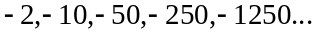
The sum of the first nine terms of this sequence is

- – 195 312
- – 346 292
- – 781 250
- – 976 562
- – 1 329 640

Question 5

An infinite sum is not able to be calculated for the geometric sequence given by

- 3, 1.5, 0.75, 0.375, 0.1875,…
- 48, 12, 3, 0.75, 0.1875,…
- 0.1, 0.3, 0.9, 2.7, 8.1,…
- 6, 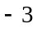, 1.5, 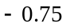, 0.375,…
E.

Question 6

The graph below shows the first five terms of a sequence where 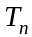 is the nth term of the sequence.
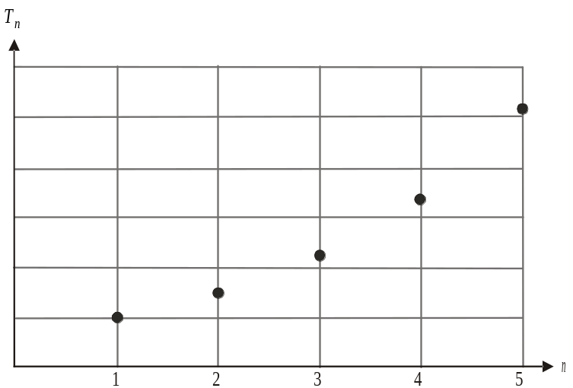

A difference equation that could generate the terms of this sequence is

- 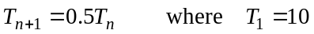
- 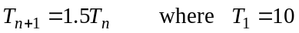
- 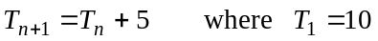
- 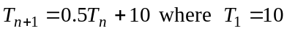

Question 7

The terms of a sequence can be generated by the difference equation 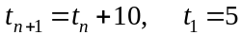.
The nth term of this sequence is given by

- 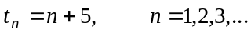
- 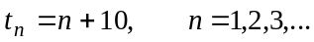
- 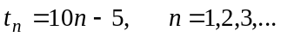
- 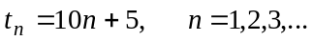
- 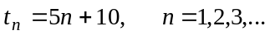

Question 8

A specialist medical facility opens with 180 patients having already been referred to it. The number of patients referred to the facility increases by 12% each month but the facility can only treat 20 patients per month. Patients need to visit the facility just once for treatment.
Let 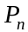 be the number of patients at the end of the nth month, who have been referred to the facility and who are currently awaiting treatment.
A difference equation that describes this situation is

- 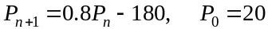
- 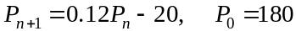
- 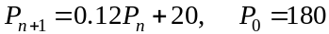
- 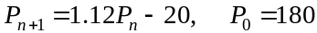
- 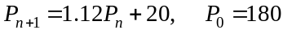

Question 9

Jo weighed 90kg when she started on a weight loss program.
She lost 5kg in the first month of the program, 4kg in the second month and 3.2kg in the third month. If Jo continues to lose weight according to this pattern, Jo will end up weighing

- 25kg
- 45kg
- 65kg
- 75kg
- 83.75kg

Module 2: Geometry and trigonometry

If you choose this module all questions must be answered.

Question 1

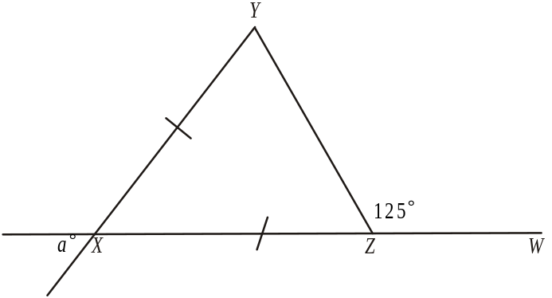

In triangle XYZ, 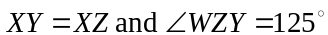.
The value of a is

- 50
- 55
- 60
- 65
- 70

Question 2

A circle has an area of 12 square metres.
The radius of the circle, in metres, is closest to

- 1.38
- 1.91
- 1.95
- 2.07
- 3.82

Question 3

A hemisphere of radius 6cm sits on top of a cylinder with the same radius and a height of 15cm.

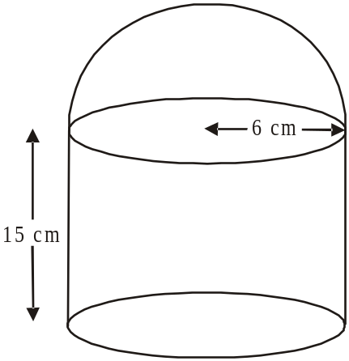

The volume of this object is closest to

- 1 753cm³
- 2 149cm³
- 2 318cm³
- 2 348cm³
- 2 601cm³

Question 4

ABC and BDE are right-angled triangles. Angle ACE is 42°, angle ABD is a right angle and the length of BE is 4 cm as shown.
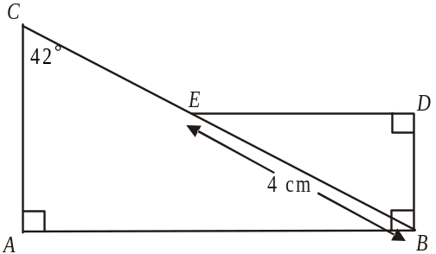

The length of BD is closest to

- 1.86cm
- 2.34cm
- 2.68cm
- 2.97cm
- 3.60cm

Question 5

In triangles ABD and BCD, . Also angle 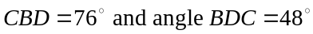.

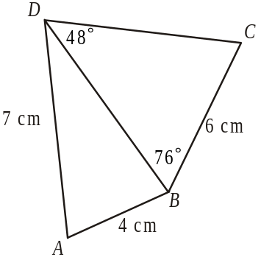

The length of BD is closest to

- 3.70cm
- 5.38cm
- 5.74cm
- 6.69cm
- 9.74cm

Question 6

Two similar shaped cardboard cones have volumes of 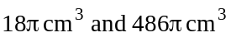.
The height of the smaller cone is 6cm.
The radius of the larger cone is

- 3 cm
- 6 cm
- 9 cm
- 18 cm
- 27 cm

Question 7

A right pyramid ABCDV has a square base with side lengths of 6cm. The slanted edges of the pyramid are 5cm.

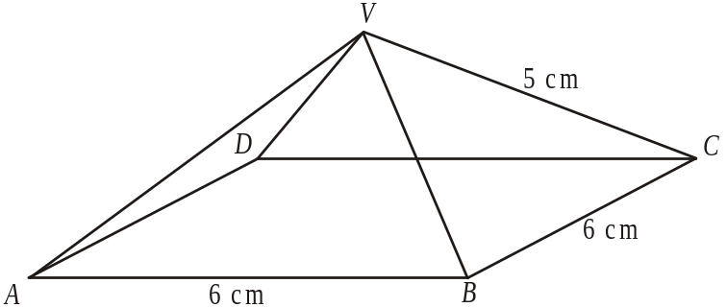

The angle that the sloping face BCV makes with the base of the pyramid is closest to

- 37°
- 39°
- 41°
- 68°
- 72°

Question 8

A contour map for part of a quarry site covering a rectangular area indicated by ABCD, is shown below.
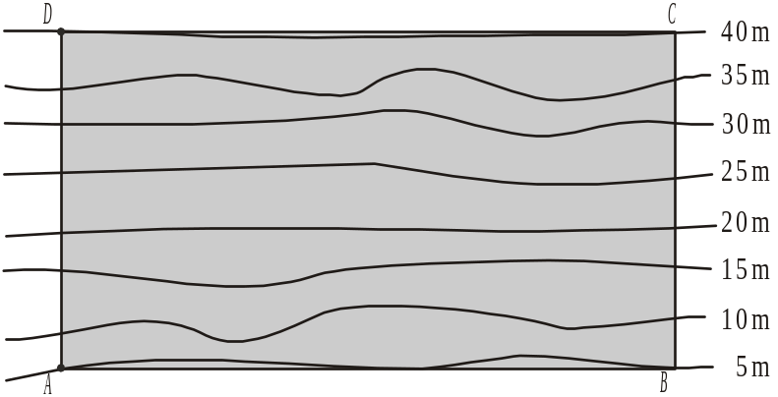

Along parts of the fence line indicated by CD the land is 40m above sea level. The contour intervals on the contour map are 5m.
A graph that shows on its horizontal axis, the cross-section for that part of the quarry along AD is
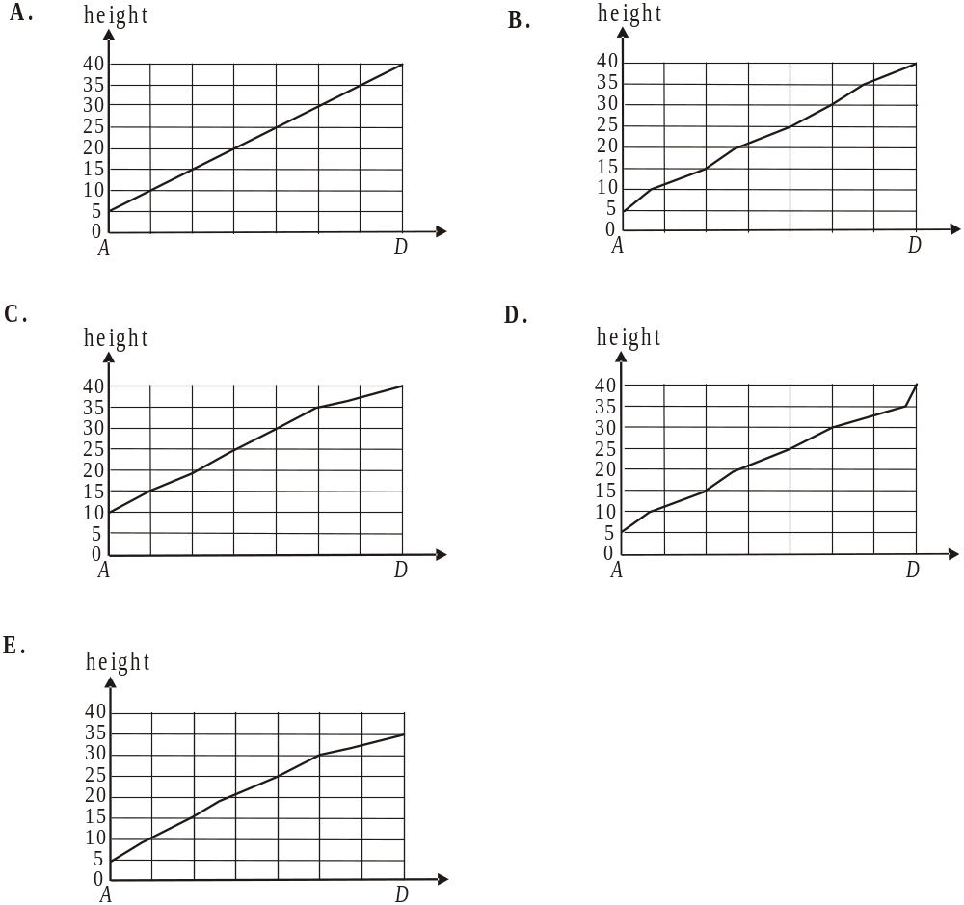

Question 9

A farmer is travelling north on a straight road that runs in a north-south direction. He leaves this road at point A and travels in a straight line on a bearing of 060° to tend a cow at point B. When finished, he travels in a straight line for 150 metres on a bearing of 330° until he meets the road again at point C.
The distance along the road from point A to point C is closest to

- 75m
- 87m
- 129m
- 173m
- 300m

Module 3: Graphs and relations

If you choose this module all questions must be answered.

Question 1
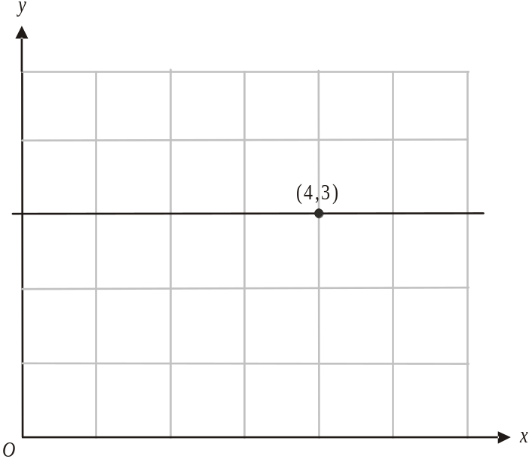

The line drawn on the graph above passes through the point 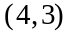.
The equation of the line is

- 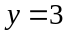
- 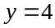
- 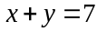

Question 2

The price P, in dollars, charged by a printer to produce n books is given by

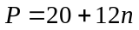

This means a client would pay

- $20 for 1 book
- $24 for 2 books
- $54 for 3 books
- $80 for 5 books
- $120 for 10 books

Question 3

The cost of hiring a floor sander for up to 8 hours is shown on the graph below.

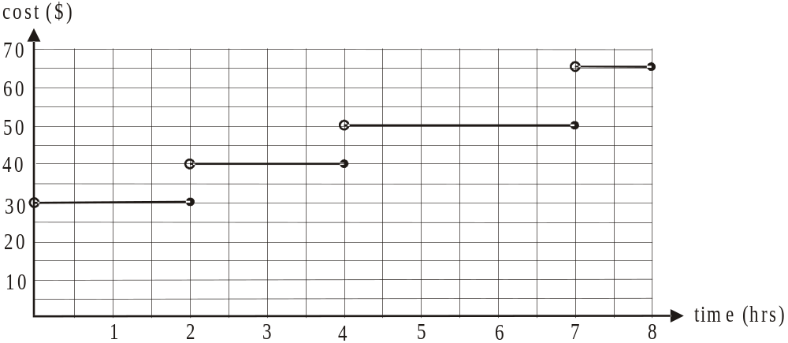

One particular day two floor sanders were hired.
The total amount paid for the hiring of these two floor sanders was $95. The times for which the floor sanders could have been hired were

- 1 hour and 7.5 hours
- 2 hours and 7 hours
- 2.5 hours and 5.5 hours
- 3 hours and 7 hours
- 4 hours and 5 hours

Question 4

The percentage humidity in a city over a 10 day period is shown on the graph below.

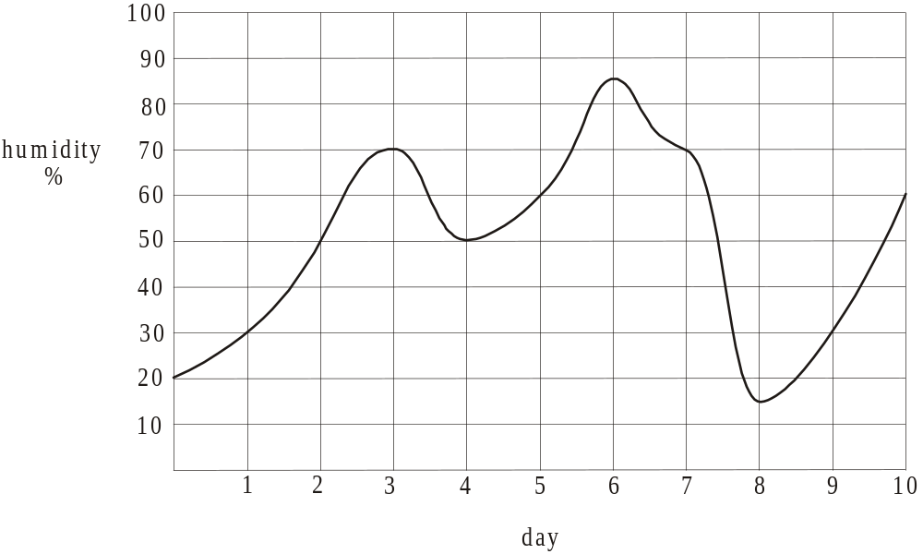

Which one of the following is not true?

- On most days the humidity was increasing.
- The average rate of change of humidity over the 10 days was 4% per day.
- The humidity was above 50% for more than 50% of the time.
- The average rate of change of humidity was the same during day 2 and day 3.
- The average rate at which the humidity changed on day 7 and day 9 was equal.

Question 5

Jack’s dog Rex has wet food and dry food each day.
Let w be the amount of wet food, in grams, Rex is fed a day.
Let d be the amount of dry food, in grams, Rex is fed a day.
There are certain constraints on the amount of wet and dry food Rex can have in a day.
The shaded area in the graph below shows the feasible region defined by these constraints. The boundaries of the shaded area are labelled with their equations.

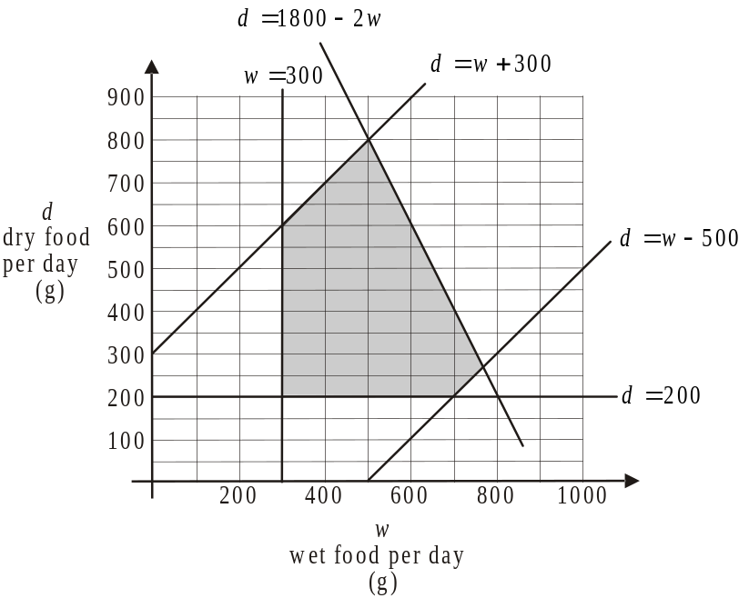

An inequality that could not be used to define the feasible region is

Question 6

The graph below is of y versus 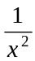.

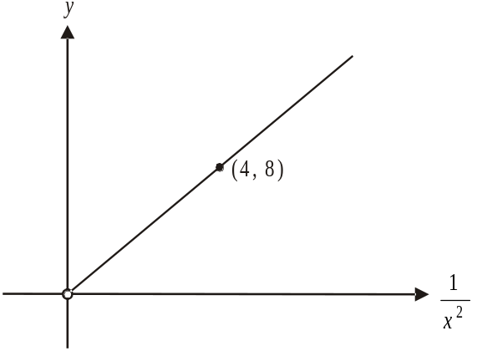

The relationship between y and x is given by the equation

- 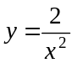
- 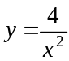
- 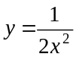
- 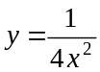
- 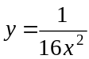

Question 7

For a retailer, the cost C, in dollars, of importing n handbags to sell is given by where a is a fixed cost.
The retailer has to sell 80 of these bags at $55 each to break even.
The value of a is

- 1 200
- 2 400
- 3 200
- 3 600
- 4 400

Question 8

Celia is a part-time student studying two subjects, English and Accounting. She can spend up to three times as much of her weekly study time on Accounting as she does on her English.
Celia has 18 hours of study time available to her every week.
Let x be the number of hours she spends studying English each week.
Let y be the number of hours she spends studying Accounting each week.
The constraints Celia has on her study time can be represented by the inequalities

- 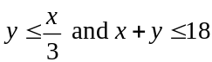
- 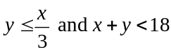
- 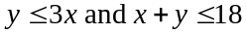
- 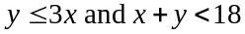
- 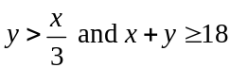

Question 9

The inequalities

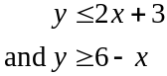

define a region.

A point that lies in this region is

- 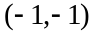
- 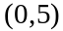
- 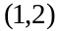
- 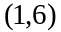
- 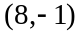

Module 4: Business-related mathematics

If you choose this module all questions must be answered.

Question 1

Tim invests $4 000 in an account earning simple interest of 2.8% per annum.
After three years the interest Tim will have earned is

- $33
- $112
- $296
- $336
- $448

Question 2

The transaction details for a credit union account for April 2013 are shown below.

Date | Transaction details | Debit ($) | Credit ($) | Balance ($)
1 April | Opening Balance |  |  | 3 290.56
7 April | Deposit |  | 300 | 3 590.56
19 April | Direct Debit | 450.00 |  | 3 140.56
30 April | Interest for April |  | 9.95 | 3 150.51
30 April | Closing balance |  |  | 3 150.51

The interest on this account is calculated on the minimum monthly balance and paid to the account each month.
The account had an annual rate of interest that is closest to

- 3.0%
- 3.2%
- 3.4%
- 3.6%
- 3.8%

The following information relates to Questions 3 and 4.

Paul bought a $600 laptop on a hire purchase plan.
He paid $100 deposit and will pay the balance in equal monthly payments for one year.
A flat rate of 9% per annum interest is charged.

Question 3

Paul’s monthly payment will be

- $41.67
- $41.98
- $42.71
- $45.42
- $54.50

Question 4

The annual effective rate of interest under this plan is closest to

- 12%
- 14%
- 15%
- 16%
- 17%

Question 5

Ky invested $7 500 in an account earning compound interest that was calculated quarterly. After two years he had earned $557.32 in interest.
The annual rate of interest he earned was

- 0.9%
- 3.6%
- 3.65%
- 6.9%
- 9%

Question 6

A retailer had a turnover of $11 500 for the month of May. If his turnover decreased by 6.2% each month over the next three months, then his August turnover would be closest to

- $5 472.64
- $7 481.76
- $8 902.44
- $9 490.88
- $10 118.20

Question 7

Pauline borrows $72 000 on a reducing balance loan. She makes monthly payments of $650 and after three years the balance remaining to be paid on the loan is $55 000.
The interest rate per annum on this loan is closest to

- 1.1%
- 3.3%
- 5.1%
- 8.3%
- 25.2%

Question 8

Jane’s salary S, in dollars, over a 6 year period is shown on the graph below.

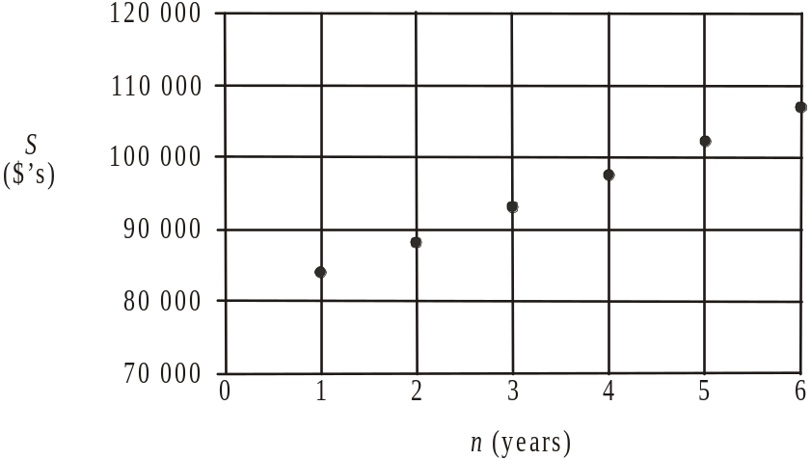

A rule that could be used to calculate Jane’s salary S, after n years could be

- 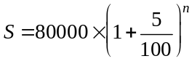
- 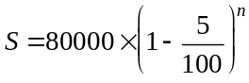
- 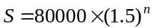

Question 9

George borrows $230 000 at an interest rate of 5.4% per annum where the interest is calculated on the reducing balance of the loan.
He makes quarterly repayments of $6 541.85 with the aim of paying out the loan in 12 years. Eight years into the loan, the interest rate increases to 5.6% per annum. In order to still pay the loan off in twelve years, George’s new quarterly payment will be

- $6 568.38
- $6 592.46
- $6 724.31
- $7 247.56
- $8 966.68
Module 5: Networks and decision mathematics

If you choose this module all questions must be answered.

Question 1

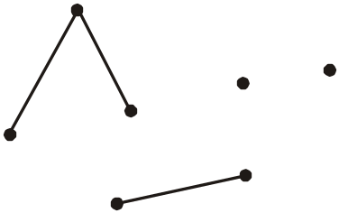

The least number of edges that need to be added to the graph above in order to make a spanning tree is

- 1
- 2
- 3
- 4
- 5

Question 2

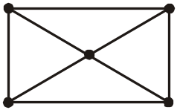

In the graph above, the number of vertices from which a Hamiltonian circuit can begin is

- 0
- 1
- 2
- 4
- 5

Question 3

The graph below shows the one-step dominances that exist between five backyard chooks, Mildred, Audrey, Rose, Norma and Portia. Mildred, for example, has a one-step dominance over Audrey, as the arrow on the graph indicates.

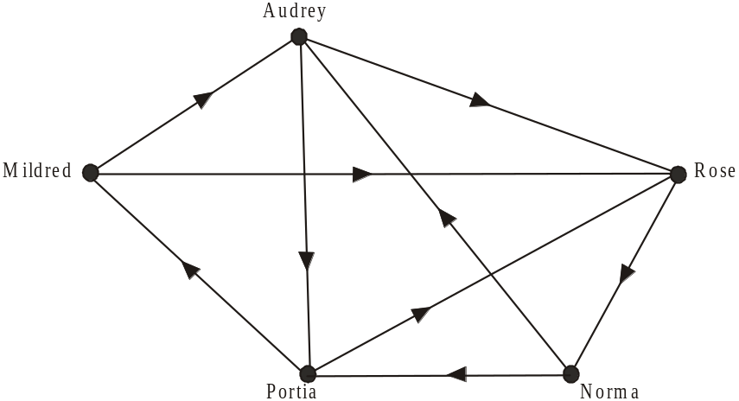

The number of chooks that Audrey has a two-step dominance over is

- 0
- 1
- 2
- 3
- 4

Question 4

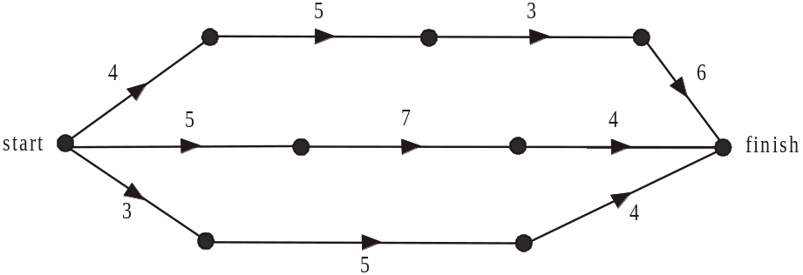

The maximum flow possible, through the network above, from start to finish is

- 8
- 10
- 12
- 14
- 18

Question 5

The adjacency matrix below represents a planar graph with five vertices.

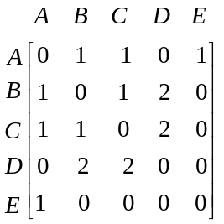

The number of faces that this planar graph would have is

- 5
- 8
- 10
- 13
- 15

Question 6

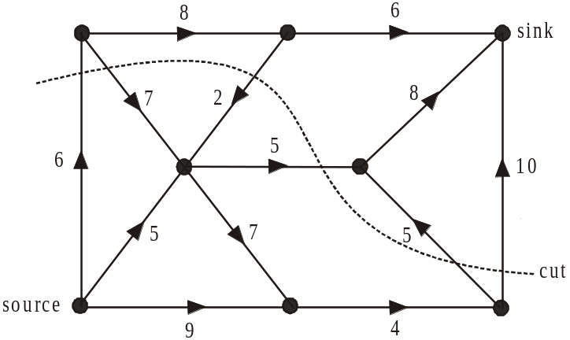

The network above gives, on each edge, the maximum flow possible between two vertices. The arrows show the direction of the flow.
A cut is shown which separates the source from the sink.
The capacity of this cut is

- 17
- 20
- 26
- 30
- 35

Question 7

An Euler circuit starts at vertex A and passes through a network. The five statements listed below are made about this network.

- The network could have an odd number of vertices.
- The degree of vertex A is odd.
- The network could be a tree.
- The network could have an odd number of edges.
- The sum of the degrees of all the vertices in the network could be odd.

The number of these five statements that are true is

- 0
- 1
- 2
- 3
- 4

The following information relates to Questions 8 and 9.

A project is made up of nine activities, A – I, that need to be completed as quickly as possible.
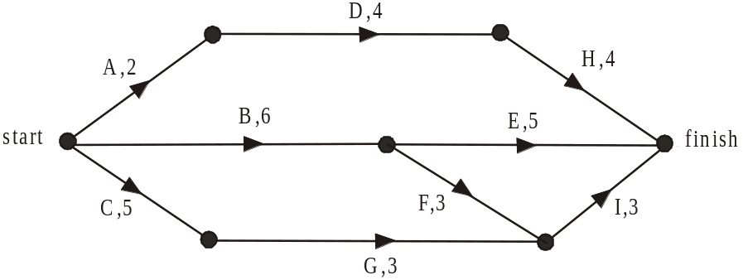

The graph above shows the time each activity takes to complete, in hours, as well as the order in which they need to be completed.

Question 8

The minimum number of hours in which this project can be completed is

- 8
- 9
- 10
- 11
- 12

Question 9

Just before the project is to begin, the manager cuts two staff from the project leaving just three staff to do it.
Jill can complete activities B and H only.
Craig can complete activities C, D and I only.
Paul can complete activities A, E, F and G only.
The minimum number of hours in which the project can now be completed is

- 11
- 12
- 13
- 16
- 35

Module 6: Matrices

If you choose this module all questions must be answered.

Question 1

The matrix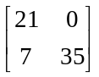 is equal to

- 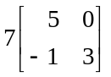
- 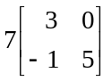
- 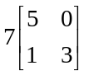
- 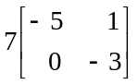
- 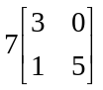

Question 2

Let 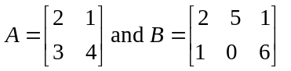.

The matrix product 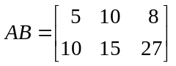.

The element in the second row and first column of matrix AB is obtained by calculating

Question 3

Given that matrix P is a matrix and matrix Q is a matrix, which one of the following matrix expressions is defined?

- PQ
- 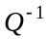
- 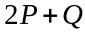
- 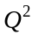
- 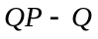

Question 4

The matrix equation 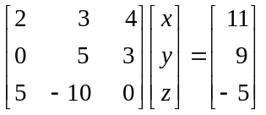 has the solution given by

- 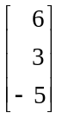
- 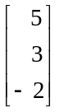
- 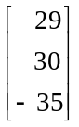
- 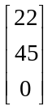
- 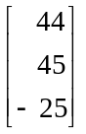

Question 5

A shoe shop takes delivery of a large consignment of shoes. The number of containers and the number of pairs of shoes in each container, is shown in the table below in each of the categories of men’s, women’s and children’s shoes.

 | Men’s | Women’s | Children’s
Number of containers | 3 | 7 | 4
Number of pairs of shoes per container | 54 | 68 | 72

The total number of pairs of shoes delivered to the shoe shop can be calculated using the matrix product.

- 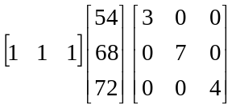
- 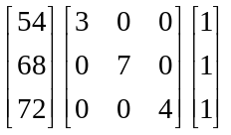
- 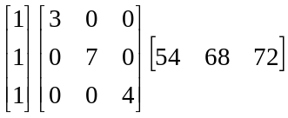
- 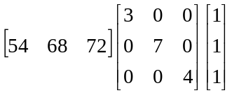
- 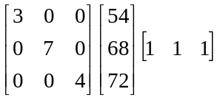

Question 6

Flights to an island are available four days a week in the morning, afternoon or evening. The number of first class, business and economy tickets still available for flights next week are shown in the table below.

 | Morning flight | Afternoon flight | Evening flight
Tuesday | 8 economy | 6 business | 1 first class
Thursday | 5 business | 3 first class | 4 economy
Saturday | 2 first class | 7 economy | 3 first class
Sunday | 3 economy | 5 business | 6 economy

Which one of the following matrices shows the availability of morning, afternoon and evening air tickets to the island in economy, business and first class next week?

- 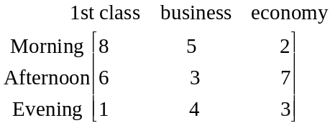

- 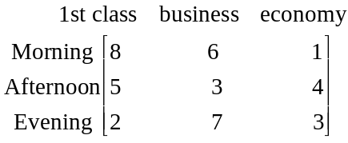

- 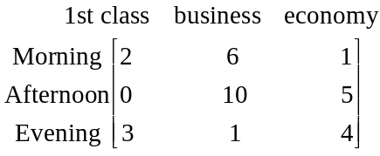

- 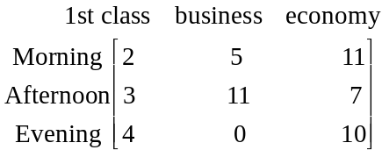

- 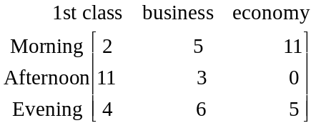

Question 7

Each week, in a particular subject, university students have a choice of attending a lecture (A) or viewing the lecture on line (O). The transition diagram below shows the way in which students change the way in which they take the lecture in from week to week.
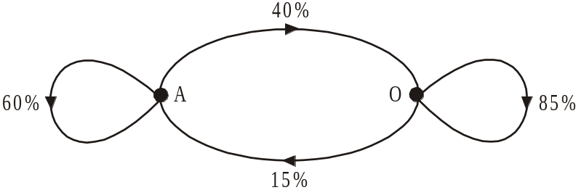

A transition matrix that represents this situation is

- 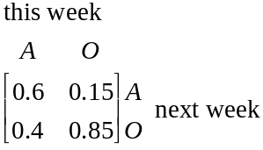

- 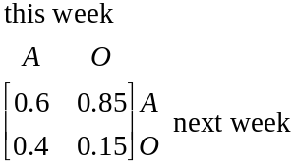

- 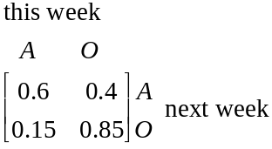

- 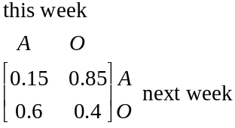

- 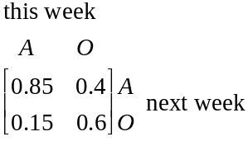

Question 8

A large city accounting firm moves offices. The staff can either drive to this office (D) or use public transport (P). A transition matrix that predicts the way staff will change their preferences each day as to how they get to the office is given by

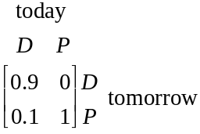

Over time, if this predicted pattern were to continue, the number of staff who drive to the office would

- decrease by 90%
- decrease by 10%
- halve
- reduce to zero
- double

Question 9

Each month 100 elderly citizens are taken to their choice of either shopping centre A or B. The elderly citizens change their choice of shopping centres according to the transition matrix.
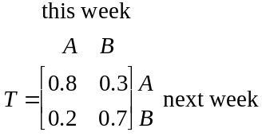

Starting from June, an extra 50 elderly citizens are added to the program each month but their destinations are fixed for their first month with 30 taken to shopping centre A and 20 taken to shopping centre B. After their first month they can choose and it is anticipated they choose in the same manner described by the transition matrix T.

The matrix 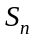 represents the number of elderly citizens visiting shopping centres A and B in the nth month. Given

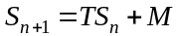, where 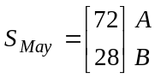 and 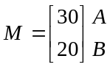

the number of elderly citizens to visit shopping centre B in July is

- 54
- 68
- 77
- 96
- 123
Further Mathematics Formulas

Core: Data analysis

standardised score: 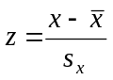
least squares line: 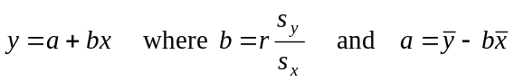
residual value: residual value = actual value – predicted value

seasonal index: seasonal index 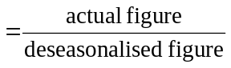

Module 1: Number patterns

arithmetic series: 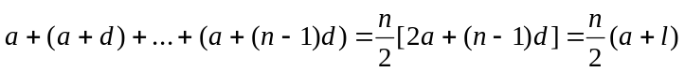
geometric series: 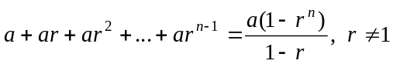
infinite geometric series: 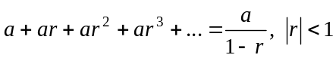

Module 2: Geometry and trigonometry

area of a triangle: 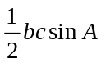
Heron's formula: 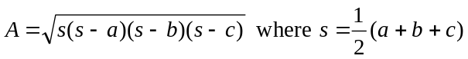
circumference of a circle: 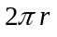

area of a circle: 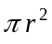

volume of a sphere: 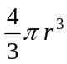
surface area of a sphere: 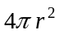

volume of a cone: 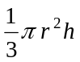
volume of a cylinder: 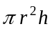

volume of a prism: 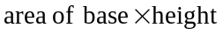
volume of a pyramid: 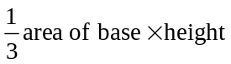

Reproduced with permission of the Victorian Curriculum and Assessment Authority, Victoria, Australia.
These formula sheets have been copied from the VCAA website www.vcaa.vic.edu.au
Pythagoras’ theorem 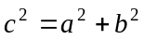

sine rule: 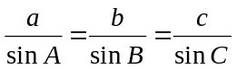
cosine rule: 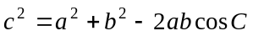

Module 3: Graphs and relations

Straight line graphs
gradient (slope): 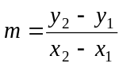
equation: 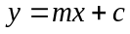

Module 4: Business-related mathematics

simple interest: 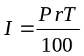
compound interest: 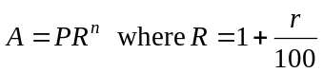
hire purchase: 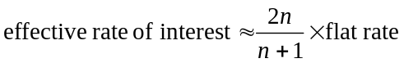

Module 5: Networks and decision mathematics

Euler’s formula: 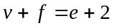

Module 6: Matrices

determinant of a 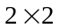 matrix 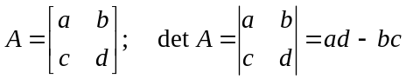
inverse of a matrix 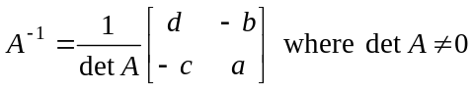

END OF FORMULA SHEET

Reproduced with permission of the Victorian Curriculum and Assessment Authority, Victoria, Australia.
These formula sheets have been copied from the VCAA website www.vcaa.vic.edu.au

